ECBN POLICY
MANIFESTO 15

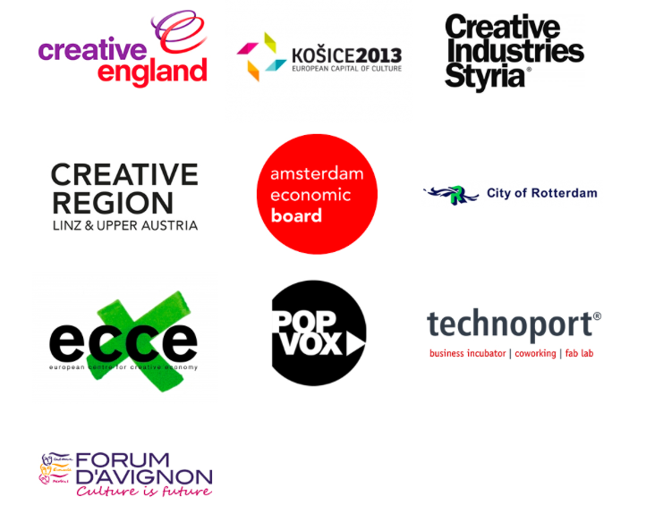
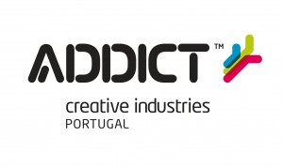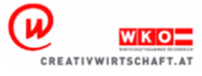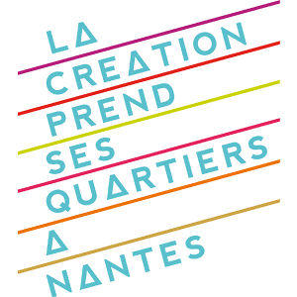

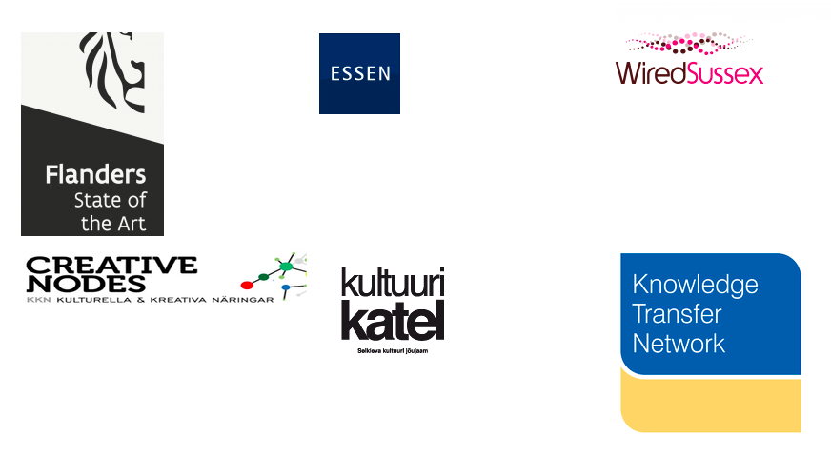

Cultural Creative Industries in the Digital Era:
- Entrepreneurial Assets and Efficiency Need More Support -

Working Paper Open to Contributions till 30 May 2015

I. Today´s Need to support the Cultural and Creative Europe
in the digital shift

The Cultural Creative Industries are a leading sector of growth and employment in Europe with €558 billion in value added to GDP (4.4% of total EU GDP) and appro 8.3 million full time equivalent jobs (3.8% of total EU workforce) according to the TERA / Forum d'Avignon Study 2014. However the report also proofs the risks of significant value destruction – unlike the overall trend of the economy – and noticeable decrease in employment in the France, Germany, Italy, Spain and the UK – partly due to the digital shift.
The European Union took up this digital challenge to one of its most important economic sectors in various manners in 2015. The Latvian EU-Presidency 2015 overall headline is:

“Europe must make active use of its cultural and creative forces.”

The European Creative Business Network (ECBN):
- sees the Cultural Creative Sectors in 2015 at a pivotal crossroad given the speed of the digital shift and its changes to the sector to finally live up to its "untapped potential in the cultural and creative sectors for boosting economic growth and job creation"
- EU Commissioner Tibor Navracsics -
and
- aims to support the European Union in "to maximise the contribution of the cultural and creative sectors to growth and job creation" with the following policy proposals derived from the experience of leading funding agencies and intermediaries for cultural and creative industries on national, regional and local level.

II. Steps to further build a more efficient and cultural Europe

The European Commission of President Juncker recognized from the very beginning the potential contributions from the cultural creative industries to growth in Europe, but also the risks emanating from the digital shift. DG Connect, DG Enterprise and Industries and DG Education and Culture already started to coordinate their work more closely to develop even more integrated strategies. The newly founded Intergroup for Cultural Creative Industries within the European Parliament is not only an important institutional progress in policy making, it already accounts for first successes in promoting the cultural creative sectors.

ECBN welcomes the new awareness for emergency and priority as well as for new integrated forms of policy making within the European Commission and the European Parliament:

We believe that the Work Plan for Culture 2015 - 2018 (as of Council Meeting 25 November 2104) is an important and effective start which can be further developed – beyond single policy debates like intellectual property rights, digitalisation or internationalization – to become a program enforcing its own demand for an integrated approach as stated:

"member states agreed that the transversal dimension of culture fitted well with the cross- sectorial approach of the Europe 2020 strategy and could therefore reinforce the effectiveness of the whole strategy, provided that an integrated approach was adopted at all levels." (3349th Council Meeting of Education, Youth, Culture and Sport, 25 November 2014, Page 11)
However such an integrated approach can still be developed further to meet especially the challenges in the digital area and its risks for employment and growth as outlined in the TERA study. Otherwise ECBN fears that currently rising expectations towards cultural creative sectors to support innovation in other sectors of the wider economy and society cannot be fulfilled.

To avoid such a performance gap, the European Creative Business Network:
- supports EU Commissioner Tibor Navracsics on this call for "breaking the silos and strengthening connections between culture and industrial policy for example, but also education, tourism or urban and regional development."

- supports EU Commissioner Günther Oettinger focus on cultural creative industries, especially to "Strengthen Europe’s position as provider of creative products and services based on individual and business creativity".

by calling for an Fully Integrated Work Plan 2016 - 2020
for the Entrepreneurial Assets of the Cultural Creative Sectors

This Work Plan should have the capacity to integrate the diverse policy tools such as

- Cross-sectoral strand of the Creative Europe program;
- Sector skills alliances and knowledge alliances in Erasmus +;
- SMEs and IT innovation strands in Horizon 2020;
- Business support actions within COSME, including the Enterprise Europe Network;
- EU Cohesion Fund, the EU Fund for Regional Development and the EU Social Fund.

and promote the three following aims:

- improve assets and capacities of cultural creative entrepreneurs (f.e. in content production, quality, management, digital resilence),
- improve innovation transfer (spillover) of cultural creative entrepreneurs into the wider economy, especially the next generation of infrastructures in the 21st century,
- improve the understanding of the contributions of cultural creative industries, especially their qualitative and quantitative share to innovation and growth which is far from being accepted.

III. A new action framework for a sustainable and long-term vision

The European Creative Business Network suggests three fields of actions for integrated strategies to implement the above outlined aims of capacity building, innovation transfer and understanding/promotion.

1. Field 1: Culture Creative Innovation for the Investment Plan in Europe

ECBN calls for a structured Innovation Transfer from the Cultural Creative Sectors to improve Infrastructure Investments. Creative Know-How can stimulate real innovation in infrastructural works.

EU is instrumental as a role model for all levels of politics and economics to set up such know-how transfer structure and to break sectorial silos nationally, regionally and locally.
ECBN calls for a creative industries advisory subgroup to the Investment Task Force of the Investment Plan for Europe.
ECBN calls to invest 1% of the 300 Billion Euro Investment Plan in to innovative spillover effects of cultural creative industries into infrastructural works.

2. Field 2: Culture Creative Factories for Growth in Europe

Content Production in the Cultural Creative Sectors has been based an cross-sectorial inspiration for centuries (From Raffaello in Italy to Picasso Atelier in Paris!). Today Creative Factories and Hubs are the European Silicon Valleys of the Cultural Creative Industries providing clustering benefits and economies of scale in the digital know-how economy. Newest studies from British Council, ADDICT, Forum d‘Avignon and ECBN prove Hubs´ infrastructural importance for the cultural creative production in the digital age.

ECBN call on the EU Commission for an Investment Plan of 50 Mio. Euros from 2016 - 2020 in the Future of Cultural Creative Hubs and Factories in the fields of management and content capacities.
EU is instrumental to get hubs ready for international growth - not only focused on regional and national importance - and thus help to develop cultural diversity as well as production of books, music, videogames, movies, TV series, plastic arts and theatres in Europe.

3. Field 3: Digital Capacities for Entrepreneurial Success

The Digital Shift changes Markets and Business Models in all sectors, also and foremost in the cultural creative sectors as „content providers“ to the ICT industries. While the ICT industries are investing and inventing new digital tools, the cultural creative sectors need to massively adopt and use them. Investments in digital projects are too often reduced to both a belief that this is not core business and a heavy pressure on existing business models. Moreover, the potentials for growth for SMEs in the Culture Creative Sectors are often untapped because they do not use digital tools such as Big Data or Open Data at their best.

ECBN calls for a Digital Capacity Building Program of Cultural Creative Entrepreneurs. The European Union – specifically- could enable the nations to provide tax breaks for cultural creative entrepreneurs when investing in digital infrastructures. These tax breaks enable the cultural creative entrepreneurs to set up their production line for „content“ –the costs for car factories can be fully tax deducted! – and could be limited to three years in total to an amount of 5% of the turnover of the cultural creative industries in each nation.

We do believe in Europe, we do believe in the power of culture, we do wish real improvements for a new generation of Cultural and Creative Entrepreneurs. By improving the infrastructures in these three dimensions:

Innovation Transfer – The 1% Rule
Factory Frameworks – The 50 Mio. Euro Investment
Digital Capacity – The 5 % Rule

We shall improve the assets and capacities of cultural creative entrepreneurs and plan for the future, beyond the year 2020.

The Working Paper / Your Contribution

The ECBN Policy Manifesto 2015 is a working document which is open for your contribution and proposals for concrete policy actions till 30 May 2015.

ECBN wants to involve the stakeholders in the cultural creative industries on local, regional and national levels in policy making at the European level and calls for your engagement and collaboration to strengthen our common case and legitimacy in European politics.

The ECBN Policy Manifesto 2015 was drafted by Laure Kaltenbach, Forum d´Avignon, Joke van Antwerpen, Amsterdam Economic Board, and Bernd Fesel, Chair ECBN.

Please mail your contribution till 30 May to bernd@ecbnetwork.eu

The final version of ECBN Policy Manifesto will be published on June 15th.

